1. Code the recursive function to find the nth fibonacci number in the series

The Fibonacci sequence is as follows the 0th and 1st number are 0 and 1 respectively and every number after is equal to the sum of the previous two numbers. (function should return integer)

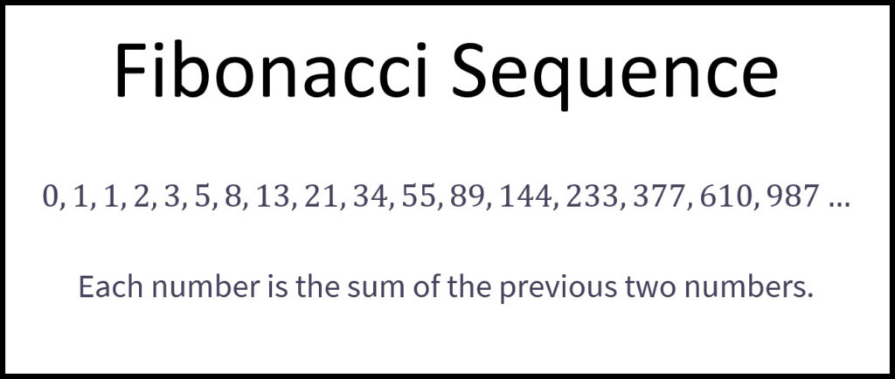

1. Code the recursive function to find out whether an integer that is passed is a power of two. (the function should return a Boolean value)